11.3.1 Editors - Compositor Editor - Sidebar - Item Tab
Item Tab - Node Panel 2
Name 2
Label 2
Color submenu 2
Color checkbox 2
Presets 2
Color 2
Node color specials 2
Copy Color 2
Item Tab - Properties Panel 3
Item Tab - Properties Panel with Image node 3
Image Property 3
Image Browser 3
New / Open 4
Image Edit Box 4
Fake User 4
Open Image 4
Remove 4
Source 4
Source Type Generated 4
X / Y 4
Float Buffer 4
Generated Type Blank 4
Color 4
Generated Type UV Grid 5
Generated Type Color Grid 5
Color Space 5
View as Render 5
Source Type Movie + Image Sequence 5
Path edit box 5
Pack 5
Path edit box 6
Open 6
Refresh 6
Info string 6
Frames 6
Match Movie Length 6
Start 6
Offset 6
Cyclic 6
Auto Refresh 6
Deinterlace 6
Color Space 6
Alpha 7
View as Render 7
Source Type Single Image 7
Path edit box 7
Pack 7
Path edit box 7
Open 7
Refresh 7
Info string 7
Color Space 7
Alpha 8
View as Render 8
Item Tab - Properties Panel with Movie Clip node 8
Color Space 8

Item Tab - Node Panel

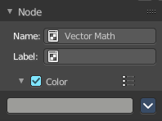
The node panel allows you to give nodes and node groups a name and a label, and change its color.

Name
The type of the node.

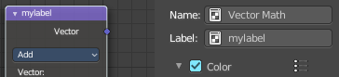
Label
The label name of the node.

Color submenu

Color checkbox
The Color checkbox turns custom color on or off.

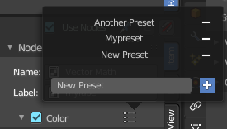
Presets
Store some color presets and reuse them. They are stored globally, and transfers to other blend files.

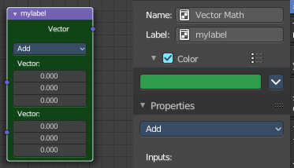
Color
Choose a custom color. A click at the color field will open a colorpicker.

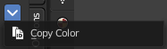
Node color specials

Copy Color
Allows you to copy the color.


Item Tab - Properties Panel
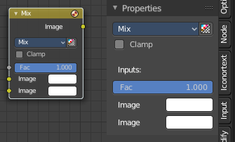

This panel shows usually the same properties than the properties at the node. These properties are already explained in the Add menu chapters. So we won't repeat them here.

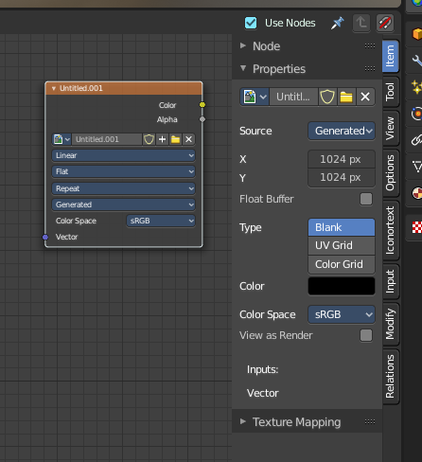
But there are exceptions like the Image node. Here the Properties panel shows much more options than at the node. It shows all the possible image settings. We will explain the extra options here.

Item Tab - Properties Panel with Image node
Contains image related settings. Size, type, and so on.

Image Property
Load an image and / or switch to other images.
From left to right ...




Image Browser
This is a list of the images in the scene. Allows you to switch to other images.

New / Open
When nothing is loaded then you will see the New / Open buttons to load a new image, or to create a new one.

Image Edit Box
The name of the currently selected image. And you can rename the image here too.

Fake User
Wit this button you assign a fake user to this selected image.
Data, like images, that is not longer linked to anything else gets removed when you save and reload a scene. Bforartists has the concept of fake users to go around this behaviour. An image with a fake user is in fact linked to something. And so it is not lost when you save and reload the scene.

Open Image
Load a image.

Remove
Delete the image.

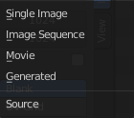
Source
Choose the image type. This type gets usually automatically set. When you create a new image, then this image is generated. When you load an image then the Source switches to Single Image.
Generated images does not have a path.

Source Type Generated

X / Y
The image width and height.

Float Buffer
Use a floating point buffer. 8 Bit images uses integers. 32 Bit works with floats.


Generated Type Blank
This type displays an image with one blank color

Color
The color of the blank image.


Generated Type UV Grid
This type displays an with a black and white checker texture but colored dots.


Generated Type Color Grid
This type displays an with a colored checker texture with numbers.


Color Space
Choose the color space type for the image.

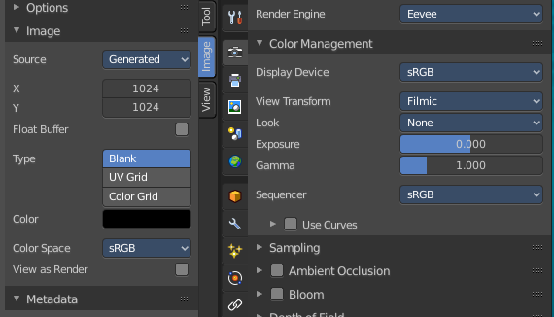
View as Render
Displays the image with the color management settings.

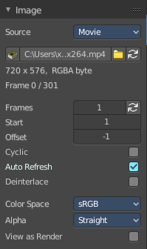
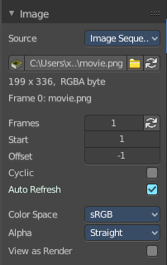
Source Type Movie + Image Sequence


Path edit box

Pack
With this button you can pack the movie or the image sequence into the blend file. It gets packed when you save the blend file the next time.

Path edit box
See and edit the path to your movieor image sequence files.

Open
Open a new movie or image sequence files. A file dialog will appear.

Refresh
Reread the movie or image sequence files.

Info string
Some information about the currently loaded movie. Frames, resolution and colorspace.

Frames
The number of frames of the movie or image sequence.

Match Movie Length
Set Users Image Length to the one of this video.

Start
The start frame of the movie or image sequence

Offset
Offset the number of the frame to use in the animation. -1 means off.

Cyclic
Cycle the images in the movie.

Auto Refresh
Always refresh image on frame changes.

Deinterlace
Deinterlace the movie file on load.


Color Space
Choose the color space type for the movie or image sequence files.

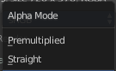
Alpha
Choose the alpha channel mode. Straight or Premultiplied.

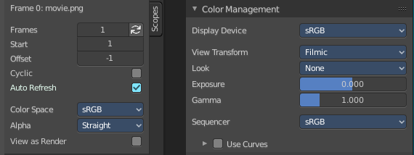
View as Render
Display the image with using the color management settings.

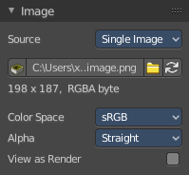
Source Type Single Image

Path edit box

Pack
With this button you can pack the movie or the image sequence into the blend file. It gets packed when you save the blend file the next time.

Path edit box
See and edit the path to your movieor image sequence files.

Open
Open a new movie or image sequence files. A file dialog will appear.

Refresh
Reread the movie or image sequence files.

Info string
Some information about the currently loaded image. Resolution and colorspace.


Color Space
Choose the color space type for the movie or image sequence files.

Alpha
Choose the alpha channel mode. Straight or Premultiplied.

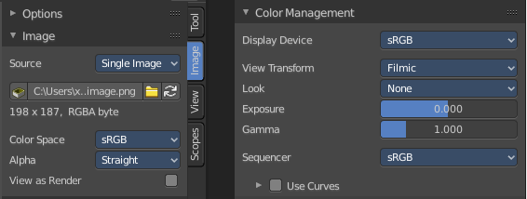
View as Render
Display the image with using the color management settings.

Item Tab - Properties Panel with Movie Clip node
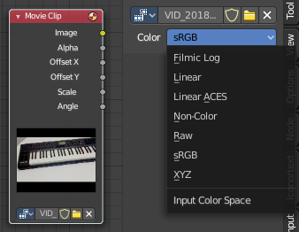

Color Space
Choose the color space for the imported movie.

